**Name : Aarya Tiwari**

**Batch : B2:**

**Roll No. : 16010421119**

**Course: Web-Programming II**

**Tutorial No. : 1**

**Codes and Outputs**

1. **Arithmetic Operators**

**Code:**

<?php

    echo "Hello World! <br>";

    $a = 11;

    $b = 57;

    echo "Number 1 is " . $a . "<br>";

    echo "Number 2 is " . $b . "<br><br>";

    $c = $a + $b;

    echo $c . " -- Addition <br><br>"; *// Addition*

    $d = $a - $b;

    echo $d . " -- Subtraction <br><br>"; *// Subtraction*

    $e = $a * $b;

    echo $e . " -- Multiplication <br><br>"; *// Multiplication*

    $f = $a / $b;

    echo $f . " -- Division <br><br>"; *// Division*

    $g = $a % $b;

    echo $g . " -- Modulus <br><br>"; *// Modulus*

    $h = $a ** $b;

    echo $h . " -- Exponentiation <br><br>"; *// Exponentiation*

?>

**Output:**

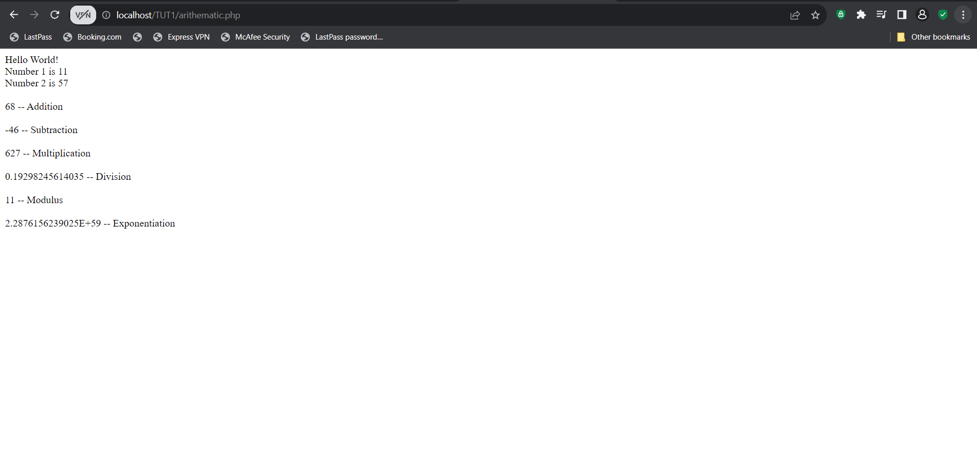

1. **Assignment Operators**

**Code:**

<?php

    echo "Hello World! <br>";

    $a = 11;

    $b = 57;

    echo "Number 1 is " . $a . "<br>";

    echo "Number 2 is " . $b . "<br><br>";

    $k = $a += $b;

    echo $k . " -- Addition Assignment <br><br>"; *// Addition Assignment*

    $l = $a -= $b;

    echo $l . " -- Subtraction Assignment <br><br>"; *// Subtraction Assignment*

    $n = $a *= $b;

    echo $n . " -- Multiplication Assignment <br><br>"; *// Multiplication Assignment*

    $o = $a /= $b;

    echo $o . " -- Division Assignment <br><br>"; *// Division Assignment*

    $p = $a %= $b;

    echo $p . " --  Modulus Assignment <br><br>"; *// Modulus Assignment*

    $q = $a **= $b;

    echo $q . " -- Exponentiation Assignment <br><br>"; *// Exponentiation Assignment*

?>

**Output:**

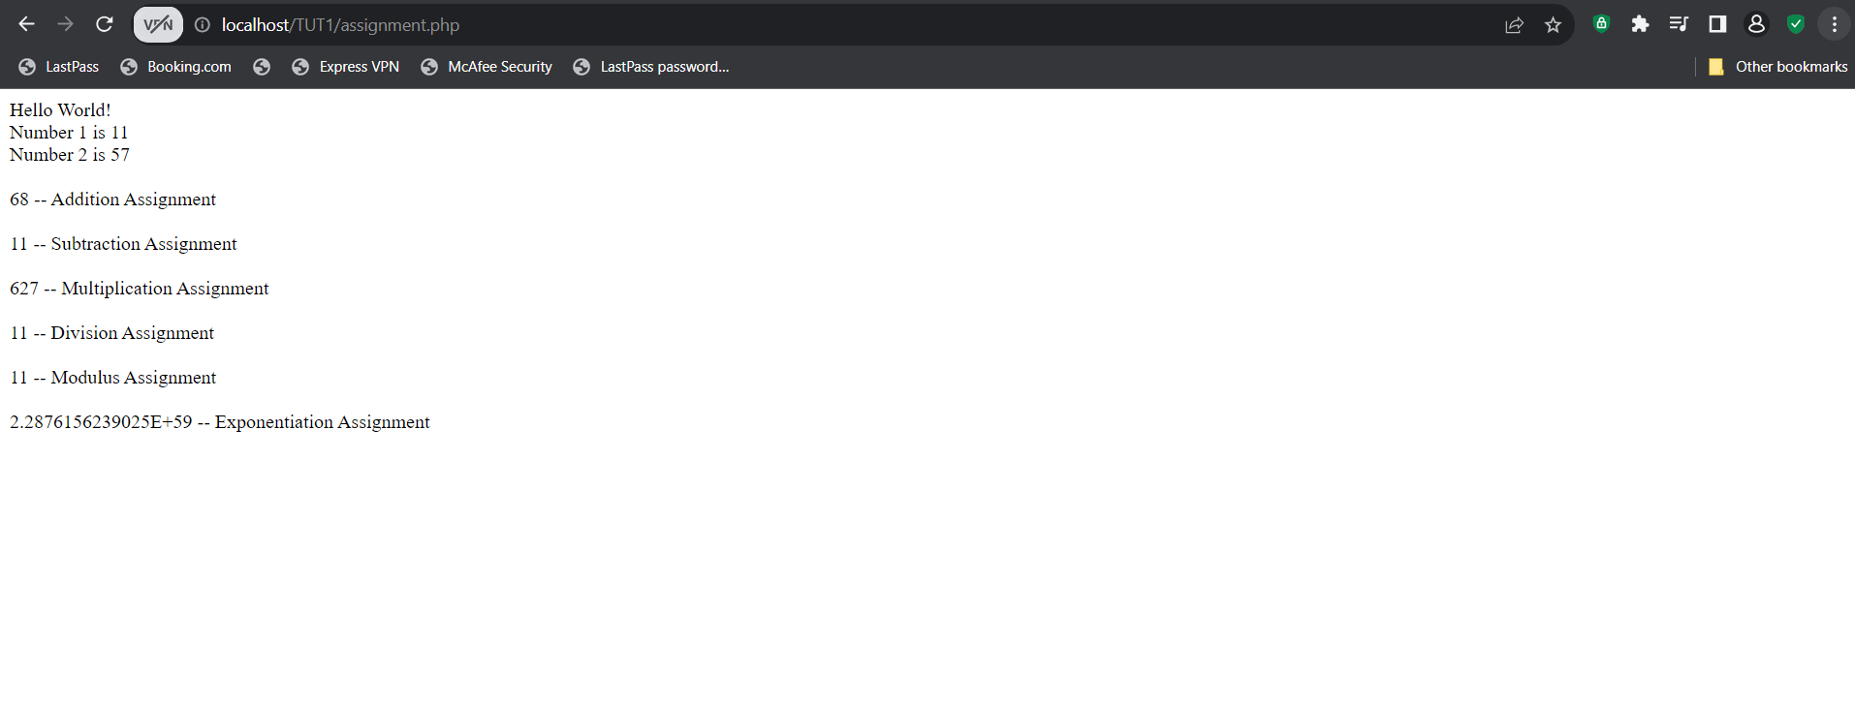

1. **Bitwise Operators**

**Code:**

<?php

    $abcd = 57;

    $abce = 11;

    $hello = $abcd & $abce;

    echo $hello . " -- And <br><br>"; *// And*

    $ae = $abcd | $abce;

    echo $ae . " -- Or <br><br>"; *// Or*

    $af = $abcd ^ $abce;

    echo $af . " -- Xor <br><br>"; *// Xor*

    $ag = ~$abcd;

    echo $ag . " -- Not <br><br>"; *// Not*

    $ah = $abcd << $abce;

    echo $ah . " -- Shift Left <br><br>"; *// Shift Left*

    $ai = $abcd >> $abce;

    echo $ai . " -- Shift Right <br><br>"; *// Shift Right*

?>

**Output:**

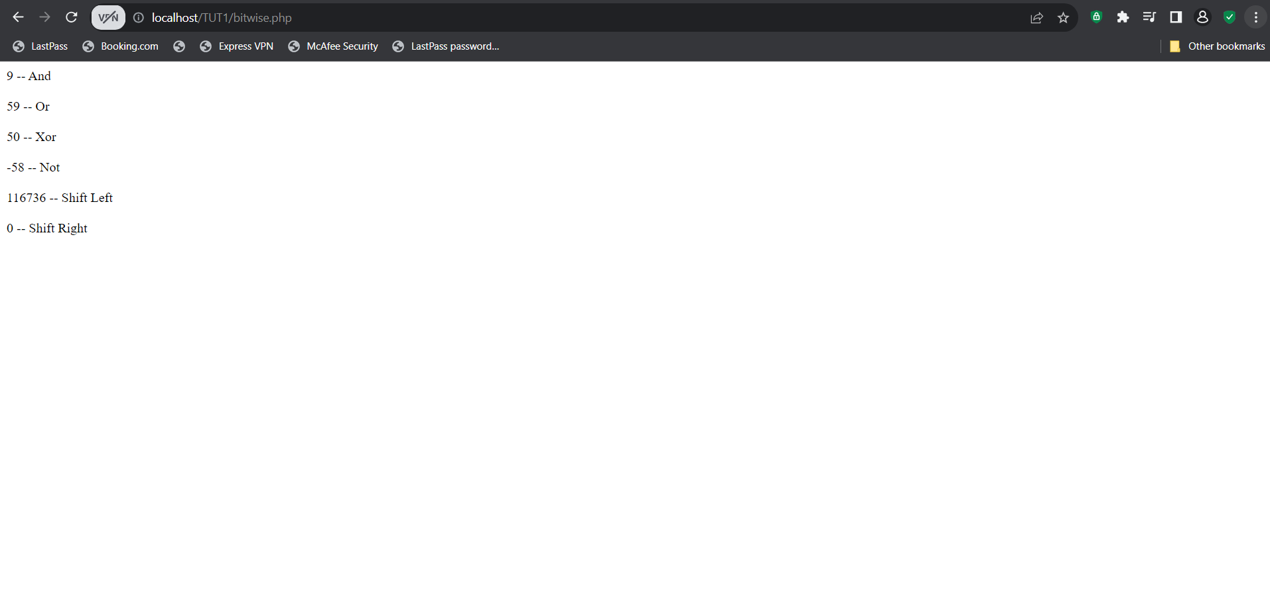

1. **Comparison Operators**

**Code:**

<?php

    $abcd = 57;

    $abce = 11;

    $a = 10;

    $b = "10";

    if ($a == $b) {

        echo "Equal<br><br>";

    } else {

        echo "Not Equal<br><br>";

    }

    $a = 10;

    $b = 20;

    if ($a != $b) {

        echo "Not Equal<br><br>";

    } else {

        echo "Equal<br><br>";

    }

    $a = 10;

    $b = "10";

    if ($a === $b) {

        echo "Identical<br><br>";

    } else {

        echo "Not Identical<br><br>";

    }

    $a = 10;

    $b = 10.0;

    if ($a !== $b) {

        echo "Not Identical<br><br>";

    } else {

        echo "Identical<br><br>";

    }

    $a = 15;

    $b = 10;

    if ($a > $b) {

        echo "Greater than<br><br>";

    } else {

        echo "Not Greater than<br><br>";

    }

    $a = 15;

    $b = 20;

    if ($a < $b) {

        echo "Less than<br><br>";

    } else {

        echo "Not Less than<br><br>";

    }

    $a = 20;

    $b = 20;

    if ($a >= $b) {

        echo "Greater than or equal to<br><br>";

    } else {

        echo "Not Greater than or equal to<br><br>";

    }

    $a = 15;

    $b = 20;

    if ($a <= $b) {

        echo "Less than or equal to<br><br>";

    } else {

        echo "Not Less than or equal to<br><br>";

    }

?>

**Output:**

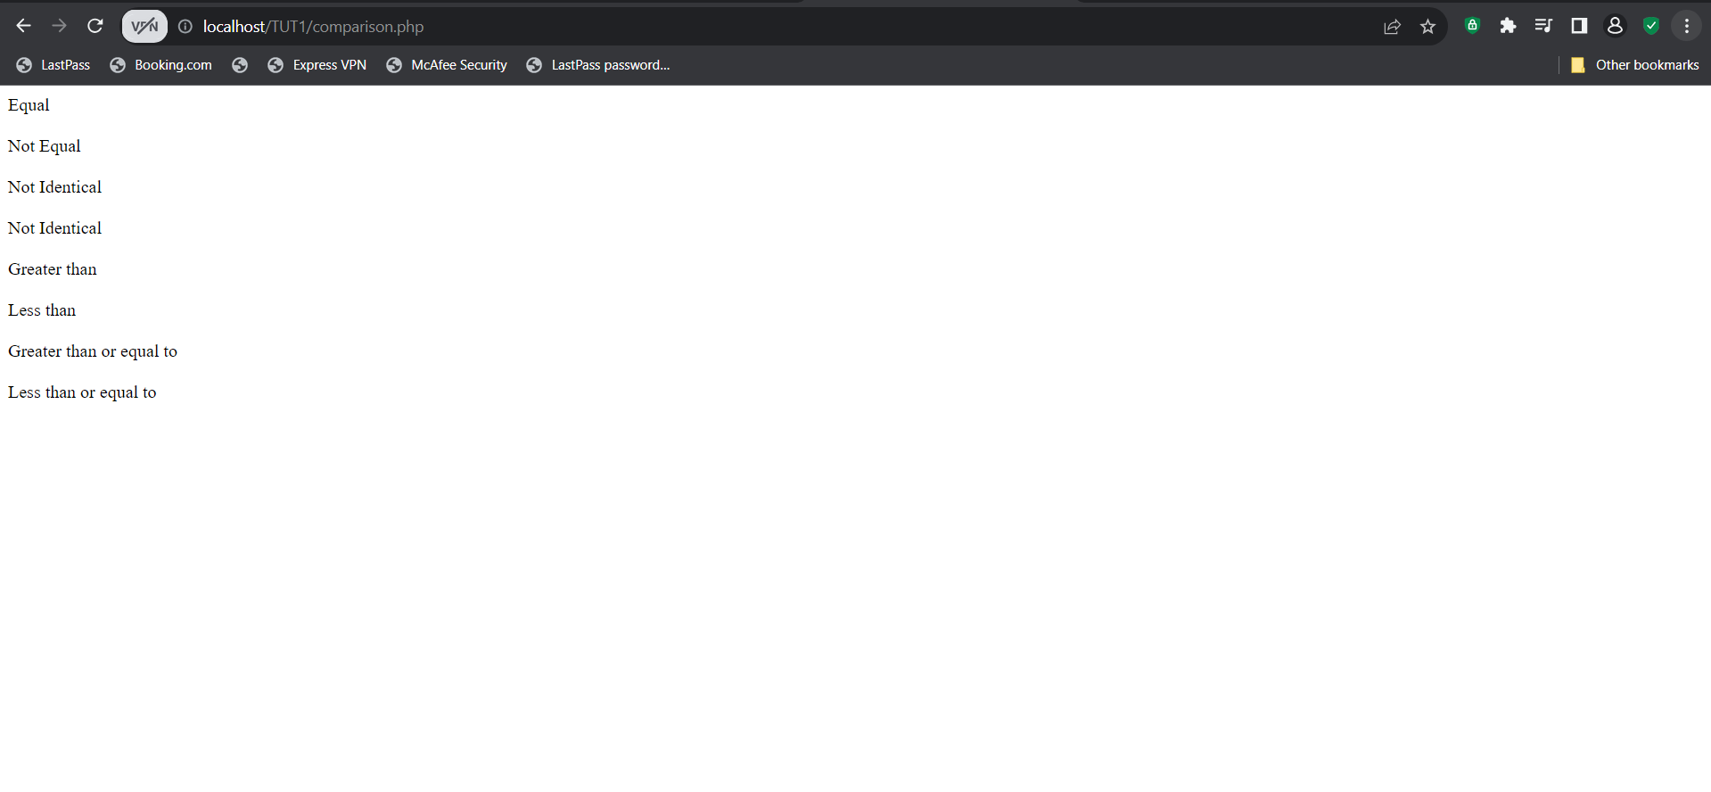

1. **Incrementing/Decrementing Operators**

**Code:**

<?php

    echo "Hello World! <br>";

    $a = 11;

    $b = 57;

    echo "Number 1 is " . $a . "<br>";

    echo "Number 2 is " . $b . "<br><br>";

    $i = $a++;

    echo $i . " -- Increment Addition <br><br>"; *// Increment*

    $j = $a--;

    echo $j . " -- Decrement Addition <br><br>"; *// Decrement*

?>

**Output:**

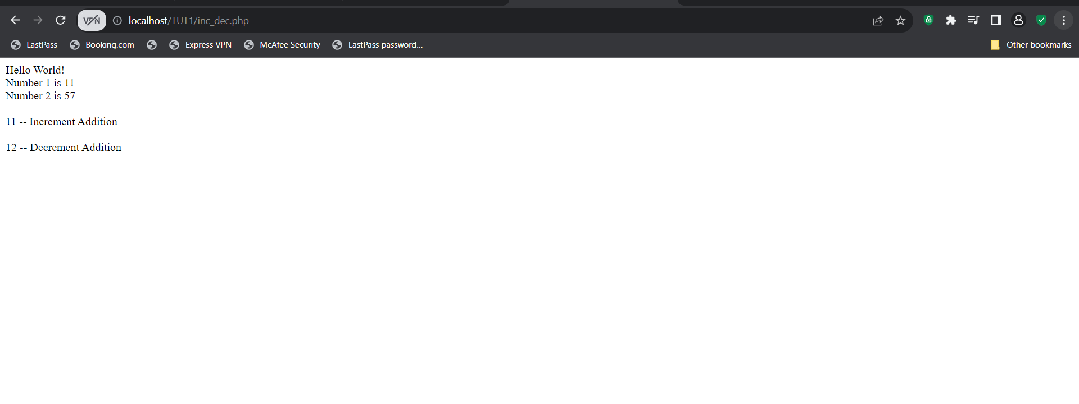

1. **Logical Operators**

**Code:**

<?php

    $a = true;

    $b = false;

    if ($a and $b) {

        echo "True<br><br>";

    } else {

        echo "False<br><br>";

    }

    if ($a or $b) {

        echo "True<br><br>";

    } else {

        echo "False<br><br>";

    }

    if ($a xor $b) {

        echo "True<br><br>";

    } else {

        echo "False<br><br>";

    }

    if (!$a) {

        echo "True<br><br>";

    } else {

        echo "False<br><br>";

    }

    if ($a && $b) {

        echo "True<br><br>";

    } else {

        echo "False<br><br>";

    }

    if ($a || $b) {

        echo "True<br><br>";

    } else {

        echo "False<br><br>";

    }

?>

**Output:**

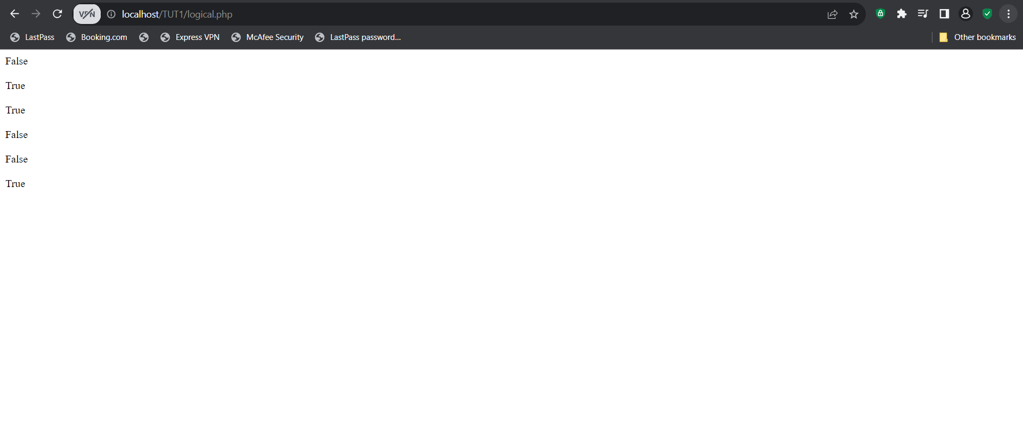

1. **String Operators**

**Code:**

<?php

    $a = "Hi my name is ";

    $b = "Aarya";

    echo $a . $b . "<br><br>"; *// Concatenation*

    echo $a .= $b . "<br><br>"; *// Concatenation Assignment*

?>

**Output:**

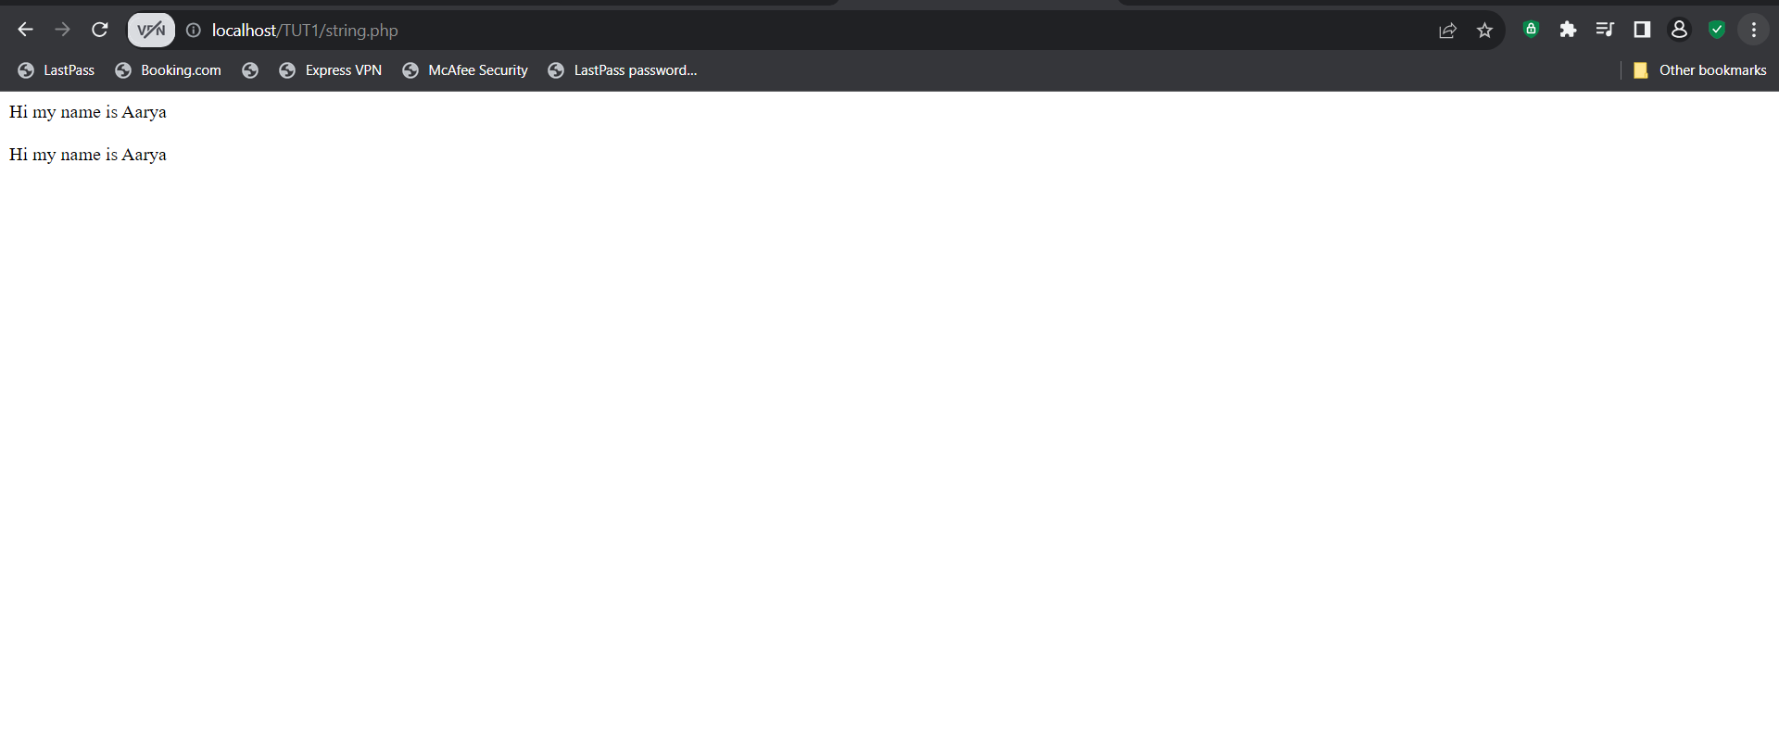

1. **Array Operators**

**Code:**

<?php

    $a = array(11, 12, 13, 14, 15, 16, 17, 18, 19, 20); *// Array*

    echo $a[0] . "<br><br>"; *// Array Index*

    echo $a[1] . "<br><br>"; *// Array Index*

    $b = array("Aarya", "Aaryan", "Aarav", "Aarush", "Aarohi"); *// Array*

    echo $b[0] . "<br><br>"; *// Array Index*

    echo $b[1] . "<br><br>"; *// Array Index*

    $c = array("Aarya" => 11, "Aaryan" => 12, "Aarav" => 13, "Aarush" => 14, "Aarohi" => 15); *// Associative Array*

    $d = array("Aarya" => 11, "Aaryan" => 12, "Aarav" => 13, "Aarush" => 14, "Aarohi" => 15); *// Associative Array*

    print_r($c + $d); *// Union*

*// $c + $d . "<br><br>"; // Union*

    $a = [1, 2, 3];

    $b = [1, 2, 4];

    if ($a != $b) {

        echo "<br>Arrays are not equal.<br><br>";

    } else {

        echo "<br>Both arrays are equal.<br><br>";

    }

    $a = [1, 2, 'three'];

    $b = [1, 2, '3'];

    if ($a === $b) {

        echo "Both arrays are identical.<br><br>";

    } else {

        echo "Arrays are not identical.<br><br>";

    }

    $a = [1, 2, 3];

    $b = [1, 2, 3];

    if ($a !== $b) {

        echo "Arrays are not identical.<br><br>";

    } else {

        echo "Both arrays are identical.<br><br>";

    }

    $a = [1, 2, 3];

    $b = [1, 2, 4];

    if ($a <> $b) {

        echo "Arrays are not equal.<br><br>";

    } else {

        echo "Both arrays are equal.<br><br>";

    }

?>

**Output:**

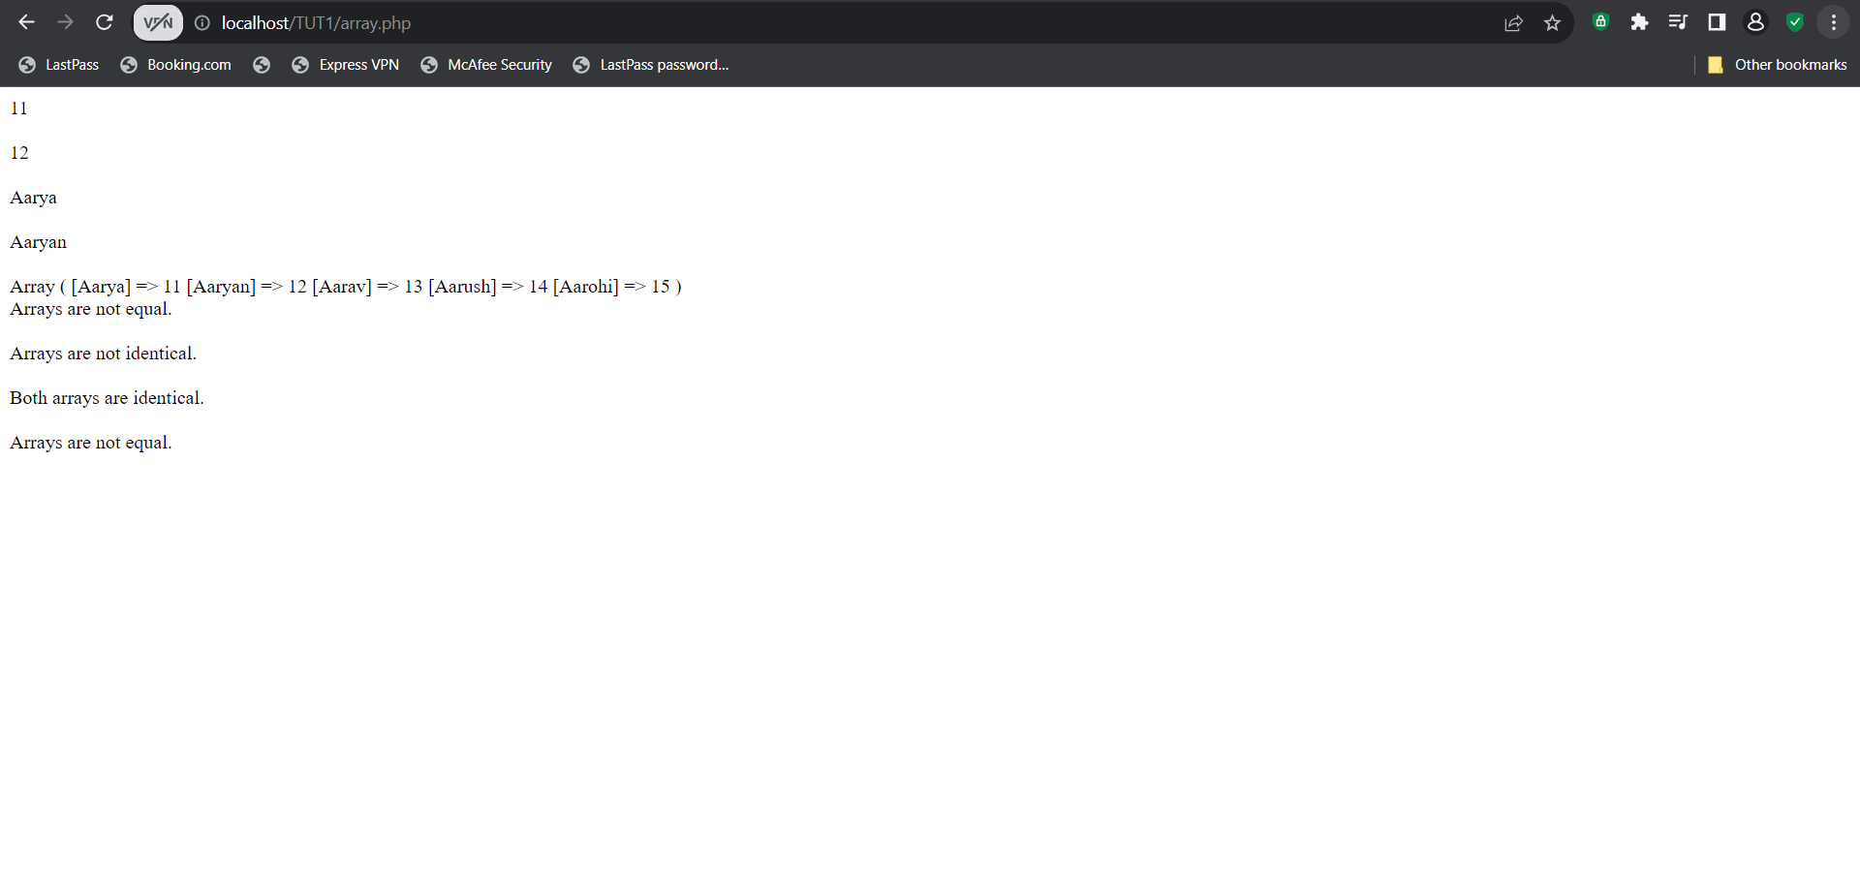

1. **Type Operators**

**Code:**

<?php

    class Student *// Class*

    {

        public $name;

        public $age;

        public $gender;

        public $rollno;

        public $marks;

    }

    $a = new Student(); *// Object*

    $a->name = "Aarya";

    $a->age = 11;

    $a->gender = "Male";

    $a->rollno = 1;

    $a->marks = 100;

    if ($a instanceof Student) { *// Instanceof*

        echo "$a->name is a Student.";

    }

    else {

        echo "Not a Student.";

    }

?>

**Output:**

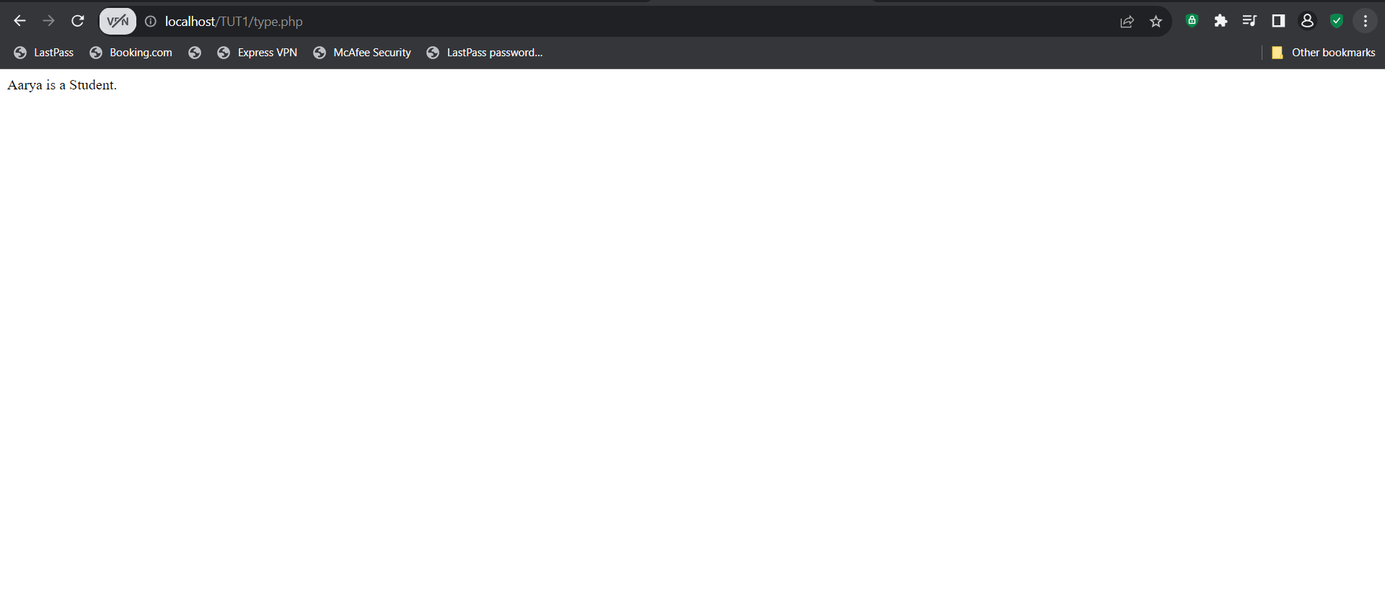

1. **Execution Operators**

**Code:**

<?php

    echo `ippconfig`; *// Backticks*

    echo `dir`; *// Backticks*

    echo `python --version`; *// Backticks*

?>

**Output:**

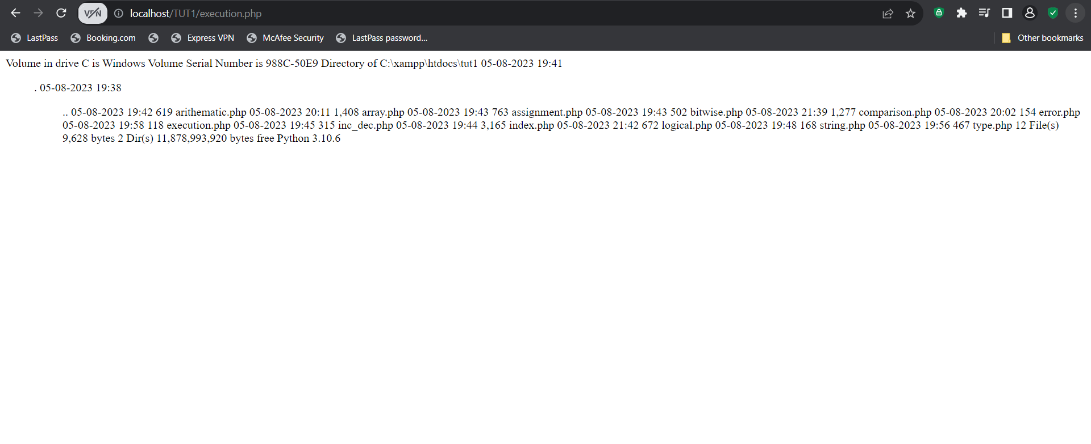

1. **Error Control Operators**

**Code:**

<?php

    function divideNumbers($numerator, $denominator)

    {

        return $numerator / $denominator;

    }

    $result = @divideNumbers(10, 0);

    if ($result === false) {

        echo "An error occurred during division.";

    } else {

        echo "Result: $result";

}

?>

**Output:**

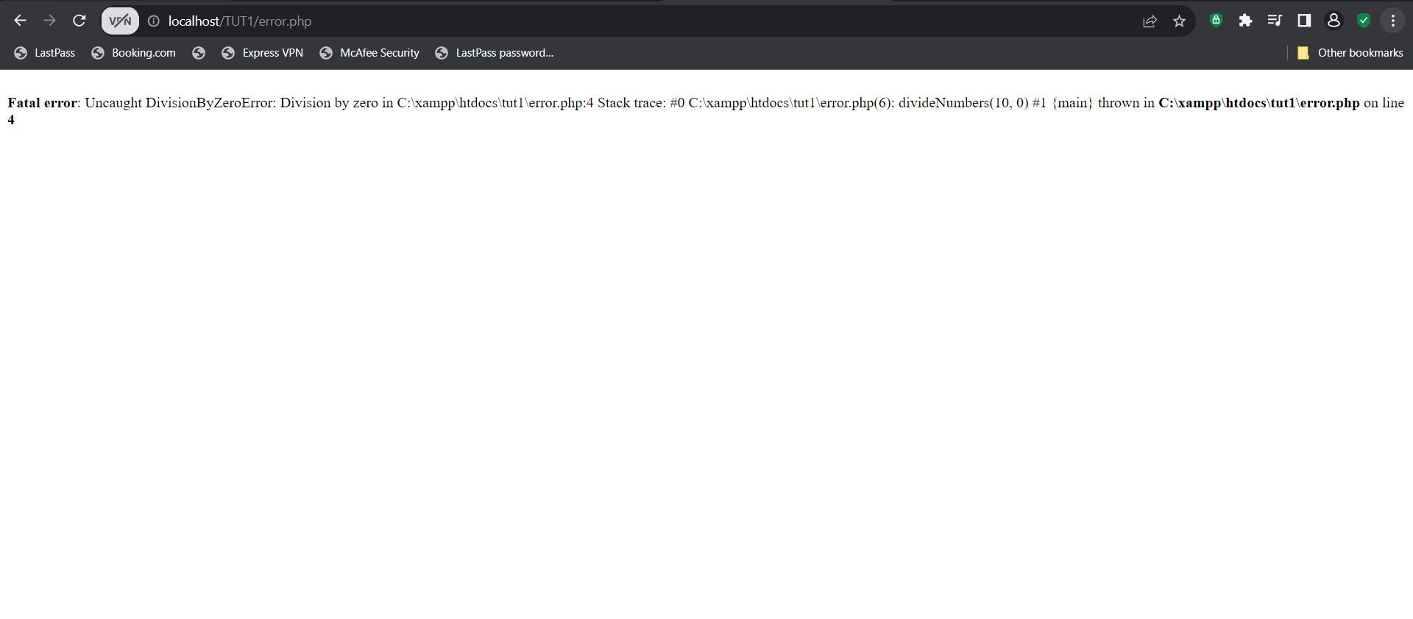

1. **For Loops + If Else Statements**

**Code:**

    $choice = 20;

    for($i = 0;$i<10;$i++)

    {

        if($i%2==0)

        {

            echo "$i is an even number!!<br><br>";

        }

        else

        {

            echo "$i is an odd number!!<br><br>";

        }

    }

**Output:**

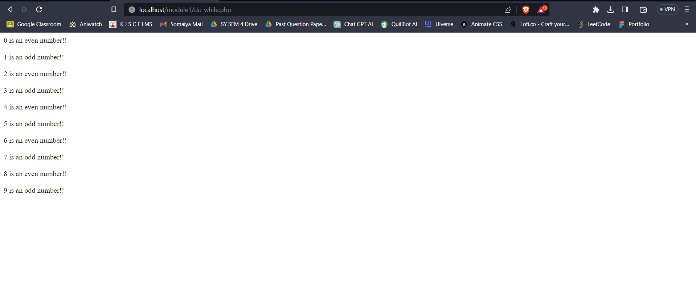

1. **While Loops**

**Code:**     while($choice>0)

    {

        if($choice%5==0)

        {

            echo "$choice is divisible by 5!!<br><br>";

        }

        else

        {

            echo "$choice is not divisible by 5!!<br><br>";

        }

        $choice-=2;

    }

**Output:**

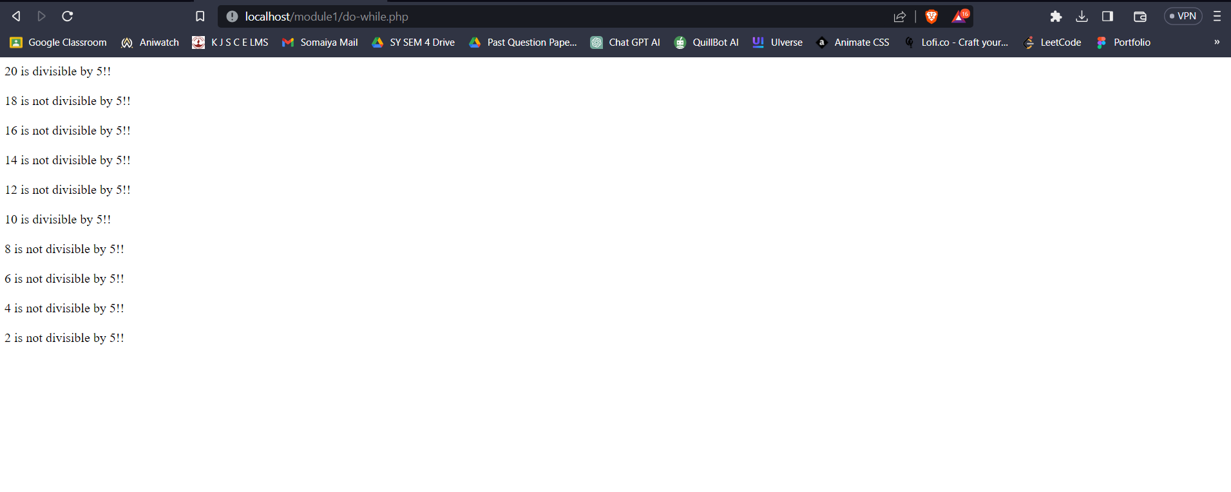

**References : javatpoint.com/php-operators**